CROPTOPIA
IDEAS // PLANBOARD

Features:

- Day and Night cycle ☑
  - At night enemies like wolves may appear, they are slightly slower than the player, however makes up for it in terms of damage
    - Daytime
      - 10 Mins IRL
    - Nightime
      - 10 Mins IRL
- Walls and fence placeables ☐
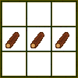
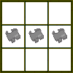
  - Obtainable from crafting menu by these recipes:

- Road assets ☐
  - Darker colored road and lighter
- Crop additions ☐
  - White Pine
    - Asset already designed, however lacks incorporation into the game
    - Old growth tree, could occur in the Dark Forests
      - Pinecone could be unique, and sell for more than the standard pinecone.
  - Wild raisin
- Phillip shop ☐
  - Tradable items, maybe decorations? ☐
    - Lantern
      - 1x Lantern = 1 USD
    - Building frame
      - 1x Building frame = 100 USD
      - Only yields the plot, you must add your resources to build it
      - Way to color it?
    - Tools
      - Shovel
        - 1x Shovel = 5 USD
      - Axe
        - Chop trees for logs
          - 1x Axe = 10 USD
    - Paint
      - Red, Blue, Yellow, White, Brown
        - 1x Paint = 2.5USD
  - Buy prices (CROPS)
    - Wheat

      - Wheat (Unprocessed)

      - Wheat Grains

      - Straws

    - Potato

  - Sell prices (CROPS)
    - Redbaneberry
      - 1 dollar/10 Crops
    - Chive
      - 1 dollar/10 Crops
    - Standard Pinecone
      - 1 dollar/15 Crops
    - White Pinecone
      - 1 dollar/10 Crops
- More resources ☐
  - Coal
  - Iron
    - Raw iron can be found in caves, and can be put into a bloom or blast furnace to be smelted into an ingot
  - Logs
    - Trees yield logs upon leftclicked with axe
  - Sap?
    - Sap could be used to make paint, maybe mixed with other sticky fluids
  - Water
    - Water could be used as an ingredient in paint
  - Grass strands
    - Grass strands could be crafted into a bio string used to combine iron and sticks into tools
    - Grass strands would be obtained by cutting overgrown grass, which then pile up at the ground, which can then be collected by forking them with the rake. 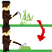
  - Wool
    - Obtained from domestic sheep (UNCERTAIN OBTAINABLE)
    - Or alternatively from a biological source
  - Dyes
    - Red, blue, green, yellow, white
    - Sources may be flowers and berries
      - Red = Red baneberry
      - Blue = Blueberries
      - Green = Grass strands
      - Yellow = Whatever yellow flower in New England
      - White = White flowers ig
  - Buildings
    - Church
      - Attending it increases your luck
    - Fishing shop?
      - Fishing rod can be gotten here
  - Mechanics
    - Luck
      - Could be used to give rarer items higher chances of yield
      - Or for rarer fish with a fishing mechanic
    - Fishing
      - Using a fishing rod the player may fish in a pond or a river
  - Storyline expansion
    - Introduction of Brock post-mt.brock
    - Brock Calligan robs Zea’s house
      - Enter’s house and a masked man collects money from zea’s storage room
      - He breaks the window and flees
    - Dialogue about it
    - Enemies – Need ideas
      - Death and damage mechanics exist as well as a doctor
      - Need enemy to make these have a purpose
      - Maybe wolves? Maybe something can trigger Brock Calligan into turning hostile?
      - Do have enemy hunt mechanic
    - Events
      - Interacting with these candidates triggers Brock’s hostility
        - Entering his house
        - [REQUIRES FEATURE] Attacking him
        - Brock has different aggression levels
          - Level 1 – Chases you with axe, killing you instantly on impact, however he moves slow
          - Level 2 – Chases you with a hunting rifle, killing you instantly
            - His axe will appear in Leo’s garden after the party, when you search for your lost watch, this is when the mandatory ‘chase’ happens
            - His rifle is not directly referenced, but there is a gun safe in his home [Off limit]
- Chests ☐
  - Used to store items, a total of 47 slots are present
- Doors? ☐
  - Rightclick opens them
- Leo’s Bar ☐
  - Leo operates a bar in the centrum of Shelburne, where he sells alcohol
- Alcohol ☐
  - Some assets for them have already been made, and they include
    - Beer
      - +15 DRPS
    - Mead
      - +15 DRPS
    - Hunter’s Liquor (Based on Jägermeister)
      - +50 DRPS
    - Red wine
      - +5 DRPS
    - Vodka
      - +85 DRPS
    - Whiskey
      - +75 DRPS
  - Another feature that may be considered is drunkenness, which is consists of 100 DRPS (Drunk Points) The more DRPS, the more uncontrollable and unconsistent your character becomes
    - Your character takes a random direction rather than the set direction
  - If you go over 100 DRPS, your character takes permanent nerfs
    - These nerfs consist of:
      - -20 Movement Speed
      - Slower tool swing
      - -20 Less max health
- Luck ☐
  - Luck can be achieved by going to the church, and by carrying a crucifix
    - Crucifix is on Michael by default
      - +10 Luck if in inventory
    - A Church is in Shelburne Centrum,
      - Entering it starts a 20 second cutscene with praises and prayers in the church
        - +20 Luck, however has a cooldown of 3 days
- Shelburne Mayor ☐
  - Shelburne has a major person in charge, and from him you can purchase land claims in a LEGAL way
    - An ILLEGAL way to claim land would be to annex and control it without authorization from the mayor, this has already been done by Lunar Crusaders.
- Making Lunar Crusader (The cult)’s settlements ☐
  - These will consist of wooden buildings and fences
    - Cultist guards are present at them
- Resource obtaining ☐
  - Sap
    - Sap can be extracted from any tree using the tapper
      - Crafted with wood and sticks
  - Stone
    - Stone will only be found in mines or on exposed mountain walls
      - Pickaxe required
- Currency ☐
  - USD
  - Obtainable through trading with Phillip
    - Here are his trades
      - 10 Red Baneberry – 1 USD
      - 10 Chives – 1 USD
      - 5 Sorrel – 1 USD
      - 15 Pinecones – 1 USD
      - 3 Elderberries = 1 USD
- Conquest ☐
  - You can capture Lunar Crusader forts in order to gain more land, however these forts are usually equipped with armed guards
- Workbenches
  - Woodworking bench
    - Used to turn logs into planks
      - Planks will be processed into sticks
  - Barrel
    - Used to make juice
  - Workbench
    - The general crafting bench
  - Blast furnace
    - Furnace intended for smelting metals
      - Recipe – Three iron ingots, iron bars, three stones
  - Campfire
  - Takes one day to cook any meat
    - Recipe – Three sticks, One coal, Three rocks
  - Grain processing table
    - Manually divides the wheat into two; the grain and the straw

Tools
    - Different tiers
      - Stone and iron

  - Axe
    - Used to chop wood, logs are obtained upon hitting trees.
  - Shovel
    - Used to acquire dirt, sand and gravel
    - Right-clicking on dirt turns set dirt tile into a bloomer furnace, which can produce a bloom every 3 days, however, the bloom furnace is one use.
      - 3 Bloom products can be crafted into a single Iron Ingot
  - Pickaxe
    - Used in caves and on exposed mountain rocks
Crops
  - Wild Strawberries
    - Domestic crop purchased from Philipps Crop Catalogue
  - Wheat
    - Domesticated crop purchased from Philipps Crop Catalogue
  - Potatoes
    - Domesticated crop purchased from Philipps Crop Catalogue
All Items/Objects:
  - Red Baneberry
    - Red Baneberries
      - Red Baneberry Seed (5x)
  - Chive
    - Chives (Bundle)
      - Chive seeds (x5)
  - Sorrel
    - Sorrel Leaf
    - Sorrel seeds (5x)
  - Elderberry Tree
    - Elderberry Clump
    - Elderberry Sap (Sap)
    - Elderberry Logs (Wood)
  - Pine Tree
    - Pinecone (Fruit)
    - Pine Sap (Sap)
    - Spruce Logs (Wood)
  - Oak Tree
    - Acorn (Fruit)
    - Oak Sap (Sap)
    - Oak Logs (Wood)
  - White Pine (Plant)
    - White Pinecone (Fruit)
      - White Pine Seeds (32x)
    - White Sap (Sap)
    - White Pine Logs (Wood)
  - Cranberry Bush (Plant)
    - Cranberry (Fruit)
      - Cranberry seeds (15x)
  - Sweetgum Tree (Plant)
    - Sweetgum (Fruit)
      - Sweetgum seeds (1x)
    - Sweetgum Sap (Sap)
    - Sweetgum Logs (Wood)
  - Birch Tree (Plant)
    - Birch Catkin (Fruit)
      - Birch seeds (32x)
    - Birch Sap (Sap)
    - Birch Logs (Wood)
  - Maple Tree (Plant)
    - Maple samara (Fruit)
      - Maple seeds (2x)
    - Maple Syrup (Sap)
    - Maple Logs (Wood)
  - Wheat (Plant)
    - Wheat Bundle (Fruit)
      - Wheat Grain
        - Wheat seed
      - Straw
  - Wild Strawberry Shrub (Plant)
    - Wild Strawberry (Fruit)
      - Wild Strawberry Seeds (15x)
  - Strawberry Shrub (Plant)
    - Strawberry (Fruit)
      - Strawberry Seeds (15x)
  - Raspberry
    - Raspberry (Fruit)
      - Raspberry Seeds (15x)
  - Tomato Bush (Plant)
    - Tomato (Fruit)
      - Tomato Seeds (5x)
  - Eggplant Bush (Plant)
    - Eggplant (Fruit)
      - Eggplant seeds (7x)
  - Corn (Plant)
    - Corn Cob (Fruit)
      - Corn Seeds (32x)
  - Artichoke (Plant)
    - Antichoke (Fruit)
      - Artichoke seeds (7x)
  - Bean Vine (Plant)
    - Bean Pod (Fruit)
      - Bean seeds (5x)
  - Kale (Plant)
    - Kale Leaf (Leaf)
    - Kale seeds (3x)
  - Sunflower (Plant)
    - Sunflower head (Fruit)
      - Sunflower seeds (64x)
  - Cucumber Vine (Plant)
    - Cucumber (Fruit)
      - Cucumber seeds (3x)
  - Zucchini Vine (Plant)
    - Zucchini (Fruit)
      - Zucchini seeds (3x)
  - Pumpkin Vine (Plant)
    - Pumpkin (Fruit)
      - Pumpkin seeds (12x)
  - Tobacco Bush (Plant)
    - Tobacco Leaf (Fruit)
      - Tobacco seeds (10x)
  - Marijuana Bush (Plant)
    - Marijuana Leaf (Leaf)
    - Marijuana Flower (Fruit)
  - Oat (Plant)
    - Oat Bundle (Fruit)
      - Oat Grains
        - Oat seeds
      - Straws
  - Lettuce (Plant)
    - Lettuce (Leaf)
    - Lettuce Seeds (3x)
  - Potato Bush (Plant)
    - Potato (Fruit)
  - Red Onion (Plant)
    - Red Onion (Fruit)
      - Red Onion (Bulb) (3x)
  - White Onion
    - White onion (Fruit)
      - White onion (Bulb) (3x)
  - Garlic (plant)
    - Garlic cluster (fruit)
      - Garlic (Bulb) (5x)
  - Spinach (Plant)
    - Spinach leaf (fruit)
    - Spinach seeds (3x)
  - Pea vine (Plant)
    - Pea pod (Fruit)
      - Peas (6x)
  - Bell Pepper Bush (Plant)
    - Bell pepper (Fruit)
      - Bell pepper seeds (12x)
  - Jalapeno Bush (Plant)
    - Jalapeno (Fruit)
      - Jalapeno seeds (6x)
  - Cayenne pepper (Plant)
    - Cayenne pepper (Fruit)
      - Cayenne Seeds (12x)
  - Peanut bush (Plant)
    - Peanut (Fruit)
      - Peanut Seeds (2x)

  - Lemon Tree (Plant)
    - Lemon (Fruit)
      - Lemon seeds (3x)
  - Apple Tree (Plant)
    - Apple (Fruit)
      - Apple seeds (4x)
  - Orange tree (Plant)
    - Orange (fruit)
      - Orange seeds (2x)
  - Cherry Tree (Plant)
    - Cherry (Fruit)
      - Cherry seeds (2x)
  - Grapefruit Tree (Plant)
    - Grapefruit (Fruit)
      - Grapefruit seeds (2x)
  - Pear Tree (Plant)
    - Pear (Fruit)
      - Pear seeds (2x)
  - Plumb Tree (Plant)
    - Plumb (Fruit)
      - Plumb seeds (1x)
  - Apricot Tree (Plant)
    - Apricot (Fruit)
      - Apricot seeds (1x)
  - Pomegranate Tree (Plant)
    - Pomegranate (Fruit)
      - Pomegranate seeds (10x)

IDEAS RATHER THAN PLANS BELOW
- Brock hunts animals
  - This could be a random event occouring in Shelburne forest
- Building ideas
  - Leo’s bar (Kinda planned)
  - Brock’s shed
    - Will be deep in the forest, maybe in the dark forests?
  - Townhall
    - Mayor will recide here
  - Dr Austenaco’s Drug Shop
    - He sells medicine here
  - Phillip’s House
  - Tyler Neil’s House
  - Leo’s House
  - Fire station (Asset made)
  - Fisherman’s House
    - By the river
- Dark Forests
  - This special forest occurs north of Sherlburne forest, and lacks a trail leading to it
  - Brock frequently hangs out here
    - This is where he hunts animals
  - His Shed is located here
    - His supplies are located here, such as his archive full of books, presumably political
    - He may have a set of tools on the wall
    - He has a big map of Shelburne on the wall with pinpoints to presumable landmarks, one of which is placed on Michael’s Plot (Sandbox)
    - There is a chest there with seeds and fertilizers
- Michael ranks/roles
  - By associating with the Mayor the player may be granted ranks

- Provisional Government of New Hampshire

  - After some civil struggles, New Hampshire proclaimed it’s own Puppet Government of the United States

- Quests
  - There will be a tab/window for quests implemented
    - Ideas for quests:
- Something something to get a map of Mt. Crag by Lunar Crucaders
THE UI
- These are concepts, may not be how they will look in the finished game
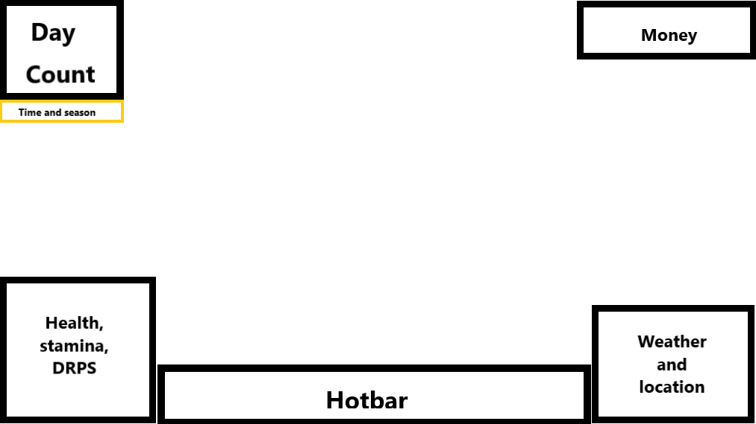
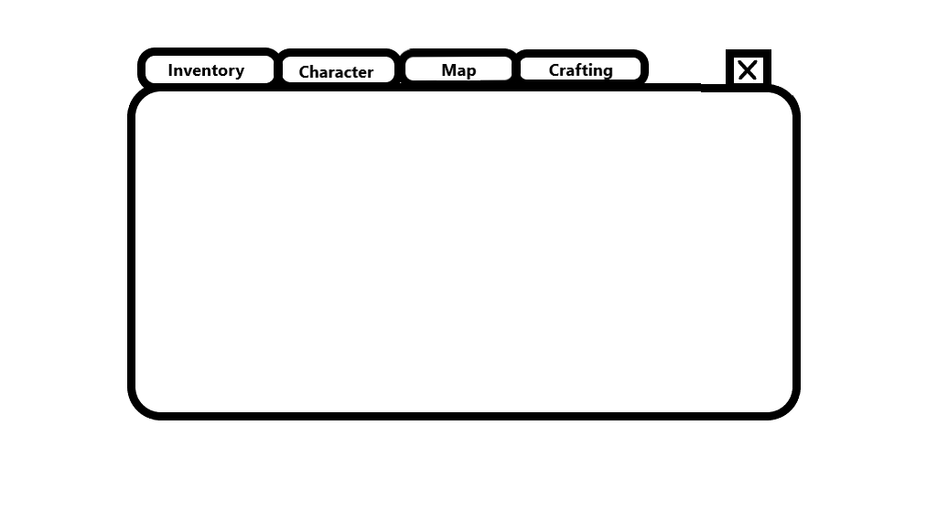
- The inventory UI will have multiple tabs for different purposes such as Character information, world map, and crafting.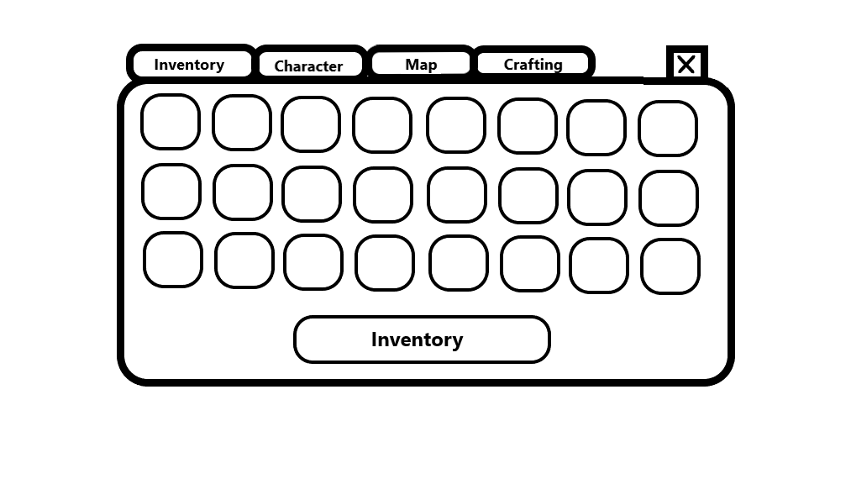
- 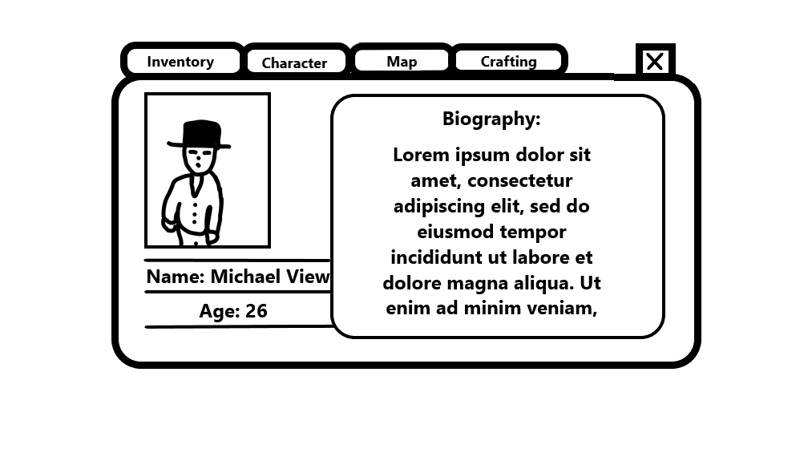

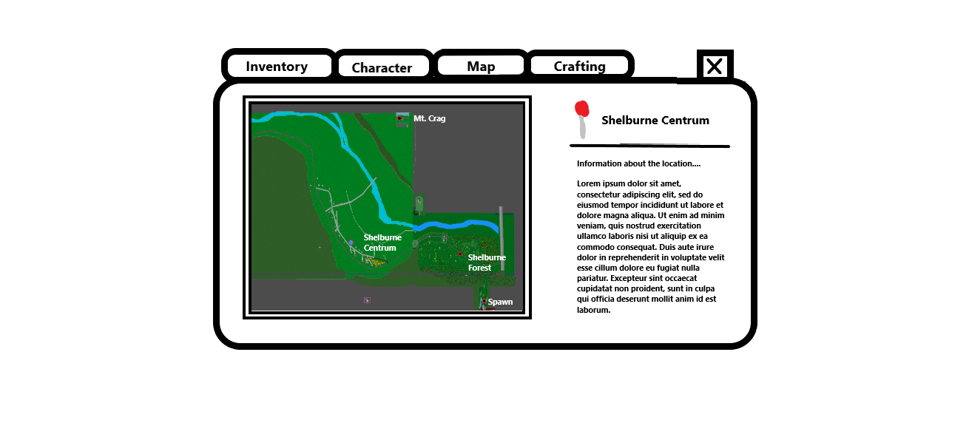

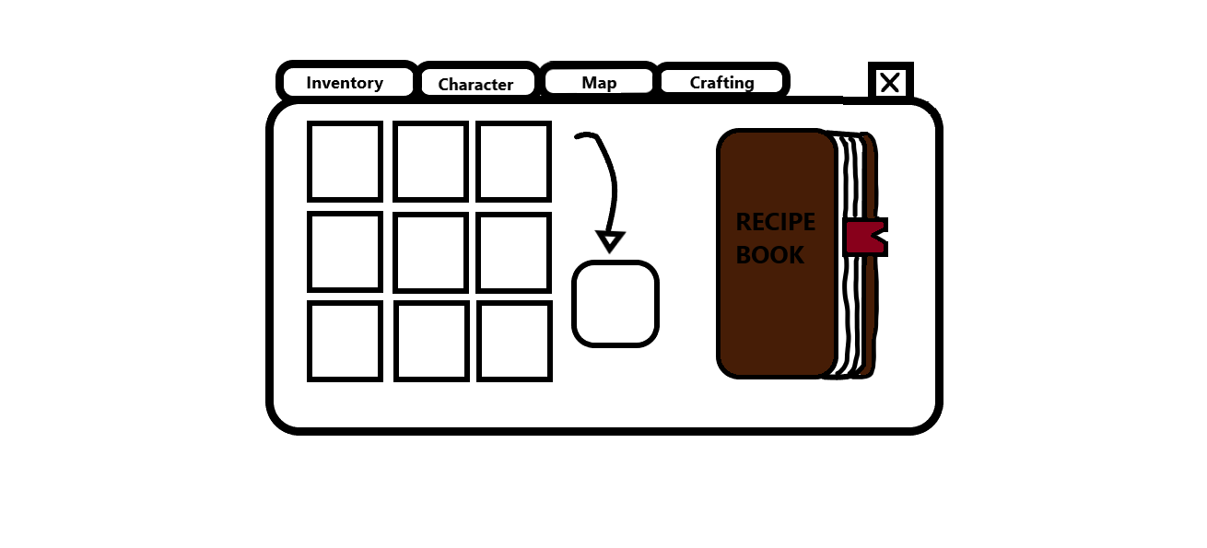

As of 9/13/2024 11:00AM it is ☑

Pokemon
Influences
- Lorem Ipsum
- Lorem Ipsum
- Lorem Ipsum
- Lorem Ipsum
- Lorem Ipsum
- Lorem Ipsum
- Lorem Ipsum
- Lorem Ipsum

Fallout
Influences
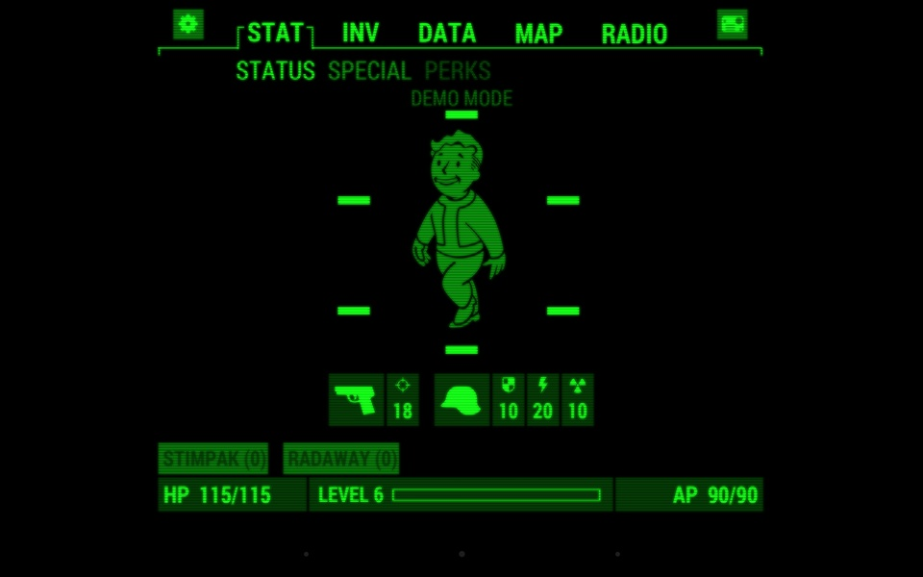

STORY IMPLEMENTATIONS
- Lunar encounters:
  - First Encounter – On the way up to mt crag you encounter a patrol group of Lunar Cultists who approach you and introduce themselves – (Occurring between the 7th and 10th day)
    - They speak of a powerful guy in a blue shirt, presumably Brock (Not mentioned by name)
      - They will not be hostile, and only have a short dialogue before leaving the scene.
  - Second Encounter - One day (Around the 90th day) you will encounter a patrol of Lunar Soldiers on the South Bank of the Androscoggin river
    - They hold you on gunpoint and demand all your money in an act of extortion.
      - This is where the Charisma mechanic comes into play, as with high charisma you can negotiate your way through to not lose that money.
      - However with low Charisma they will take all your money and flee the scene.
      - Trying to attack them will result in being shot at the scene.
  - Third scene – One day (Around the 180th day) you leave your plot to discover Lunar Soldiers around your fence
    - Among them stands Mark Gray, alongside Zea
      - He explains that due to insufficient resources, Lunar Republic have to do exclusive economic trades with Michael.
        - This may be because of santions put on by the New Hampshire Government.
      - He explains that a previously unaccessable (Guarded) location has been opened as a trade outpost which Michael can now use to trade with the Lunar Republic.
        - This outpost is in a densely forested part of the forest between Mt. Crag and Rattle Island.
          - The outpost is east of the Mt Crag trail
        - Upon entering it before this deal, you will get kicked out by the soldiers present in the area.
      - He also seems to acknowledge the prior (Canonical) shootout between the Lunar Soldiers and Michael as an unlawful breach in contract and offers to pay back a sum of 1000 USD in compensation.
      - He also talks of Lunaria’s aspiration to preserve peace between New Hampshire and condems the Neighboring Maine Army for supporting the New Hampshire’s Army.
      - He also speaks of the current economy and the local prices of Shelburne
      - Then he talks of why Lunaria would perfect the economy, and how Lunaria would improve the economy in Shelburne if it ever were in Lunarian hands.
    - Zea then steps forward
      - She explains Michael’s importance for Shelburne and his decisions will lead to big outcomes
      - Zea explains also tells Michael to not trust the Mayor, as he is a corrupted politician.
    - Leo steps forward
      - He explains how Michael’s plot may get extended if Lunaria gets in power
      - However he is still masked, and makes no talk of his identity
    - Mustafa steps forward
      - He introduces himself as General Mustafa Korkulan
      - He explains his role in the expansion of the Lunar Republic, and explains what resources are critical to the Lunar Republic
      - He also reaffirms the Lunarian support of Michael View, and his permission to enter Lunarian Territory
  - Alternative Encounters
    - Invasion of Shelburne
      - Canonical, however only happens if Michael chooses to support the Mayor of Shelburne and cut off contact with the Lunar Cult.
        - If Michael does not report to the Lunar Trade Post within 3 months
        - And if Michael negotiates with the Mayor
      - Canonically happens May 2027
        - Alternate Battle Plan – Happens if Michael conducts his trading routine with the Lunar State, gaining good relations
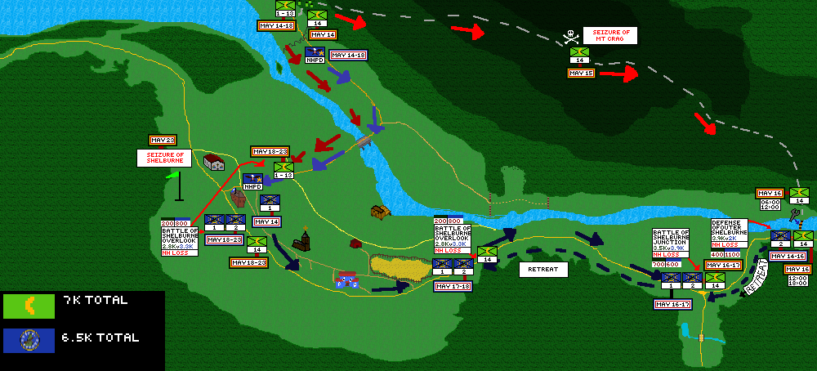
        - Timeline
          - May 14
            - The bulk of the 14th Lunar Guardsmen Regiment transits by foot from the Mt. Crag camp through the Deep Forest, hampered by difficult terrain they only reach the Mt. Crag summit by the morning of the 15th.
          - May 15
            - The 14th Regiment arrives at the summit of Mt. Crag and sets up a temporary camp, and organizes themselves for an advance towards the Northern Andrascoggin River Bank. They continue their move, however are hampered by the steep terrain, and only arrive in the early morning of May 16th.
          - May 16
            - Upon arriving at the Northern Bank, the 14th Regiment constructs a camp, while the combat engineers and vanguards make a pontoon bridge. Their advance is halted by heavy fire by the New Hampshire Army’s 2nd Regiment, the border guard units, responsible for defending the border with Maine. The bulk of the NH Army is still in Shelburne Centrum by this point, the Garrison forces, due to lack of communication.
            - By the afternoon the 14th Regiment crosses the Androscoggin River, where it destroys over 50% of the NH 2nd Regiment. After the loss the Garrison Forces (1st Reg.) finally react, and starts moving towards the Junction where they join up with the NH 2nd Regiment.
            - By the evening the NH 2nd Regiment is forced to retreat under heavy fire back to the Shelburne Junction, where they put up fierce resistance to the LG 14th Regiment, dealing more enemy casualties than own.

          - May 17th
            - However the momentum of the Lunar Guardsmen is overwhelming and by the afternoon of the 17th May they are forced to retreat to the Shelburne Overlook. This is a disaster for the NH Army, as they suffer 60% more casualties than the 14th Regiment.
          - May 18
            - The NH army is continuously pushed back from their positions and are pushed closer and closer to the town hall.
            - By the morning of the 18th, the Lunar Guardsmen are at Shelburne Centrum, contesting the roads towards the Shelburne Town Hall.
          - May 19-23
            - Hefty fighting building to building takes place southwest of the town hall from the 19th – 23rd May.
          - May 23
            - Fighting takes place in the garden of the Town Hall, mayor evacuates southeast but is captured by the 13th Lunar Guardsmen Regiment.
            - By the afternoon the white flag is raised out of the window of the town hall.
            - In the evening of the 23rd May the Mayor is tried for dissidence and executed in front of the Town Hall.
            - The rest of the prisoners of war are then presumably shot in the same manner.
- Mayor encounters:
  - First encounter – Michael enters the town hall for the first time noticing the Mayor sitting behind a table
    - He walks over to Michael introducing himself as Mayor of Shelburne.
    - He also shows interest in Michael’s farming career, and how this will be vital for the town.
  - Second encounter – Mayor visits your plot (Around the 5th Day)
    - He talks of the different services located in Shelburne, such as Phillip the Merchant.
    - He also speaks of so-called ‘Forest People’ and how they pose a threat to Shelburne and Micheal.
    - He also tells him that his office will be open and accessible for Michael at all times, and Michael can negotiate certain deals with him
- Civil separations in the United States:
  - New Hampshire, Maine, Vermont, Massachusetts, Connecticut, Rhode Island, and Albany received independence during the American withdrawal of troops from New England
    - President Donald Trump stated:
      - “Due to current internal tensions in the New English region, America have issues controlling these areas, and will have no choice to withdraw.”
    - Canonically this even takes place on May 1st 2026, around a year before the events of Croptopia.
    - The announcement was made May 1st, and full withdrawal was executed by May 15th.
    - These entities were established in New England following the withdrawal
      - Republic of Albany
      - Republic of New Hampshire
      - Republic of Maine
      - Republic of Vermont
      - Republic of Rhode Island
      - Republic of Connecticut
      - Republic of Massachusetts
    - In the months that followed some of these proclaimed states fell into big internal conflicts as proclaimed successor groups wanted to gain power.
      - Republic of New Hampshire
        - After 8 months of existing, Mark Gray founded the group the Lunar Crucaders, claiming lands in Shelburne.
        - The Lunar army gained an advantage after seeking diplomatic relations with European nations such as Serbia and Ireland, who shipped army supplies that overwhelmed the New Hampshire Republican forces.
      - Lunar Crusader State
        - A cultist entity operating out of the Northeastern parts of Mt. Crag, consisting of a large number of Cult Soldiers (Guardsmen) and Cult Followers (Worshippers) being the civilians, approximately 7000 Guardsmen strong, and with 3000 Worshippers reciding within their territory.
        - Most of these residents live a nomadic lifestyle, with mass city-like communities of tents and temporary structures.
        - The government enforces a strict law; the Conform; which reads as follows;
          - Art. 1 – Act of the People
            - A. The people [of the Lunar Crucader State] are expected to follow the words of the great Luna (Their god). Those who do not follow this will be categorized as follows;
              - Active Resistors – Treasonists
                - These are to be shot at the spot.
              - Those who don’t follow the belief (Lunar Faith) – Dissidents
                - These are to be subject to suppression, oppression, and will be forcibly converted within a year, or will face execution.
                - They are designated as alien, so Guardsmen or Policemen can freely and independently decide their fate on the spot.
              - Those (Worshippers) who sympathise or aid dissidents or treasonists – Sympathizers
                - These are to be shot at the spot.
  - START OF LUNAR CULTISM AND TERROR – FEBURARY 2027
    - May 15 – Summit Incident
      - During the seizure of the Mt. Crag summit units of the 14th Regiment shot at civilians living in houses near the summit. Other crimes they committed was ordering mass executions of the residents, and Worshippers took residence in them.
    - May 16 – Moose Pond incident
      - Workers at a local woodwork were rounded up and shot when they disobeyed orders to work for the new Lunar occupiers.
    - May 17 – Outlook incident
      - A couple of hikers were shot on the southern bank of the Androscoggin River.
    - After these incidents Mark Gray recognized the civilians of Shelburne as protected people, in order to preserve stability in the town.
    - May 23+
      - After the victory of the Lunar Guardsmen in Shelburne, Mark Gray announced Shelburne to be an protected city within the Lunar State. The terms of this classification are that, Shelburne’s population is to stay as is, the Lunar State’s Guardmen are permitted to conduct operations in and out of it, only if it does not intervene with the civillians right to move or conduct their habits.
      - Police are prohibited from entering the town, they may only transit through to move past.
      - The infamous ‘Michael View’ is mentioned multiple times in the announcement, with Mark Gray seeking to come to terms with him, recognizing his ability govern Shelburne as a client of the Lunar State.
    - Canonically Michael is forced
- Global conflicts referenced

SIMPLIFIED STORYLINE
“In *Croptopia*, a captivating 2D adventure game inspired by *Stardew Valley*, you’re transported back to 10,000 BCE to relive the dawn of farming and then brought forward to modern-day New Hampshire, where your journey as a farmer truly begins.

As Michael View, you arrive in the quiet town of Shelburne, ready to tackle the challenges of farming but starting with almost nothing—just a plot of land waiting to be cultivated. While exploring, you meet a local named Zea, who welcomes you and shares a plea for help. Her mother is unwell, and she needs a daunting list of items: from pinecones to rare berries. Eager to make a difference, you gather these resources, but the real intrigue starts after you complete this mission. When you arrive at Zea’s house to deliver the goods, she’s missing, and in her place is a mysterious figure cloaked in black. His message? “Meet us at Mt. Crag.”

This leads you to a secretive nighttime gathering atop the mountain, where Zea and others reveal themselves as part of a hidden circle of professionals. They’re not only impressed by your efforts but see potential in you as the next “generational farmer.” With a little pomp and flair, they present you with a contract, officially making you the owner of a sizable farm property.

Your farming adventure then shifts into high gear. You get a letter from Zea announcing a new store stocked with everything a farmer could dream of. The town’s shopkeeper, Philip, is so impressed by your progress that he gives you an exclusive discount on all farming essentials. It feels like things are on track… until everything takes a twist.

Zea’s home is burglarized, and you’re swept into a mystery. The townspeople are divided, and Zea is determined to find the thief. But Leo, a charismatic new ally, proposes a different path: he believes in a local legend of an abandoned facility where scientists once tried to open a portal to a world where everyday harvests are precious treasures. He suggests this might be your ticket to endless prosperity.

Now, you face a crucial choice. Join Zea in a traditional hunt for the thief, bartering harvests for clues that ultimately lead back to an unexpected suspect. Or, venture with Leo into the forest, where exotic plants and ancient locks guard the entrance to the rumored portal. With Leo’s knowledge, you could access a strange new dimension, unlocking untold farming riches.

The demo closes with a mix of sandbox freedom and story-driven quests, inviting you to dive deep into the unfolding mysteries of Shelburne. “

EVEN MORE SIMPLIFIED STORY
I’ll try my best to explain the concept of Croptopia in simple terms but basically
you play as Michael View, a farmer who arrives in the town of Shelburne. After helping a local named Zea gather rare items for her sick mother, a mysterious figure leads you to a secret group that sees potential in you as the next great farmer. They offer you a farm, sparking your journey.
The plot thickens when Zea’s money is stolen, and you’re faced with a choice: help Zea hunt down the thief or follow Leo, another villager, to a hidden facility where a rumored portal could make your crops immensely valuable. This is where Michael can access different eras such as the prehistoric Paleolithic period, in which Mammoths were freely roaming around. Your decision shapes your adventure, blending farming, exploration, and mystery in this story-driven 2D game.
THE CODE
- Day-night cycle
  - Day
    - Lasts 8 minutes
  - Sunset
    - Lasts 2 minutes
  - Night
    - Lasts 8 minutes
      - Hostility
  - Sunrise
    - Lasts 2 minutes

THE MAIN NODE SCRIPT
extends Node2D

class_name world

@export var inv: Inv
@export var item: InvItem

@onready var sunset = $ui/sunset_rect/sunset_cycle
@onready var sunrise = $ui/sunrise_rect/sunrise_cycle
@onready var sunset_rect = $ui/sunset_rect
@onready var sunrise_rect = $ui/sunrise_rect

@onready var night_rect = $ui/night_rect
@onready var night = $ui/night_rect/night_cycle
@onready var day = $ui/day_rect/day_cycle
@onready var day_rect = $ui/day_rect

@onready var player = $Node2D/objects/player

#Day counter code
@onready var day_counter = $ui/CanvasLayer/Panel/Sprite2D/count
var day_count
#
var addition = 1

var sunset_time
var sunrise_time

var night_time
var day_time

var phase
#OBJECT VARIABLES

var redbaneberry = preload("res://redbaneberry.tscn")
var chives = preload("res://chive.tscn")
var yes = false

var has_baneberry = false
var has_chives = false

var selected_redbane = false
var selected_chives = false
var redbane_collected = false
var chive_collected = false

signal redbane_placed
signal chive_placed
signal decrease_redbane

#SHOP VARIABLES

@onready var money_counter = $ui/money_count/Panel/Sprite2D/count
var money_count = 0

var redbane_sold
var chive_sold
var pinecone_sold

@onready var redbane_counter = $Node2D/objects/phillip_merchant/shop_ui/redbane_count
@onready var chive_counter = $Node2D/objects/phillip_merchant/shop_ui/chive_count
@onready var pinecone_counter = $Node2D/objects/phillip_merchant/shop_ui/pinecone_count

@export var redbane = 0
@export var chive = 0
@export var pinecone = 0

@onready var camera = $Node2D/objects/player/Camera2D
@onready var seller = $Node2D/objects/phillip_merchant

@onready var inventory = $Node2D/objects/player/CanvasLayer/Crafting_menu/Inv_UI/NinePatchRect/GridContainer/inv_UI_slot

signal update_slot
# Called when the node enters the scene tree for the first time.
func _ready():
day_count = 0
phase = "day"
day_time = true

Tilemanager.tilemap = $test2/TileMap
$test2/redbane_placeable.visible = false
$test2/chive_placeable.visible = false

money_count = 0
redbane = 0
chive = 0
pinecone = 0
redbane_sold = false
chive_sold = false
pinecone_sold = false
# Called every frame. 'delta' is the elapsed time since the previous frame.
func _process(delta):
redbane_counter.text = str(redbane)
chive_counter.text = str(chive)
pinecone_counter.text = str(pinecone)
if phase == "sunset":
sunrise_time = false
sunset_time = true
night_time = false
day_time = false
sunrise_rect.visible = false
sunset_rect.visible = true
night_rect.visible = false
day_rect.visible = false
sunset.play("day_night_cycle")

if phase == "sunrise":
sunrise_time = true
sunset_time = false
night_time = false
day_time = false
sunset_rect.visible = false
sunrise_rect.visible = true
night_rect.visible = false
day_rect.visible = false
sunrise.play("day_night_cycle_reverse")

if phase == "night":
sunrise_time = false
sunset_time = false
night_time = true
day_time = false
sunset_rect.visible = false
sunrise_rect.visible = false
night_rect.visible = true
day_rect.visible = false
night.play("night_cycle")

if phase == "day":
sunrise_time = false
sunset_time = false
night_time = false
day_time = true
sunset_rect.visible = false
sunrise_rect.visible = false
night_rect.visible = false
day_rect.visible = true
day.play("day_cycle")
#the day count \\\\\\\\\\\\\\\\\\\\\\\\\\\\\\\\\\\\\\
#\\\\\\\\\\\\\\\\\\\\\\\
# #SCRIPT FOR OBJECTS
# if redbane_collected == true:
# Tilemanager.tilemap = $test2/TileMap
# $test2/redbane_placeable.visible = true
## $test/dialogue/Sprite2D/first_philip_dialogue.visible = false
## $test/dialogue/zea/third_zea_dialogue.visible = false
# selected_redbane = true
# chive_collected = false
# selected_chives = false
#
# #THE OTHER OBJECTS
# $test2/chive_placeable.visible = false
if selected_redbane == true:
print("selected redbaneberry!")
Tilemanager.tilemap = $test2/TileMap
$test2/redbane_placeable.visible = true
$test2/chive_placeable.visible = true
# selected_redbane = true
# chive_collected = false
# selected_chives = false
if Input.is_action_just_pressed("Right-Click") or Input.is_action_just_pressed("left click"):
var redbaneberry_instance = redbaneberry.instantiate()
add_child(redbaneberry_instance)
redbaneberry_instance.position = $test2/redbane_placeable.position
emit_signal("redbane_placed")
print("working like usual")
if selected_redbane == false:
$test2/redbane_placeable.visible = false

#############################################
# if chive_collected == true:
# Tilemanager.tilemap = $test2/TileMap
# $test2/chive_placeable.visible = true
# $test2/redbane_placeable.visible = false
# selected_chives = true
# redbane_collected = false
# selected_redbane = false
if selected_chives == true:
print("selected chives!")
Tilemanager.tilemap = $test2/TileMap
$test2/chive_placeable.visible = true
$test2/redbane_placeable.visible = false
# selected_chives = true
# redbane_collected = false
# selected_redbane = false
if Input.is_action_just_pressed("Right-Click") or Input.is_action_just_pressed("left click"):
var chive_instance = chives.instantiate()
add_child(chive_instance)
chive_instance.position = $test2/chive_placeable.position
emit_signal("chive_placed")
print("working like usual")
if selected_chives == false:
$test2/chive_placeable.visible = false

func _on_sunset_cycle_animation_finished(anim_name):
phase = "night"

func _on_sunrise_cycle_animation_finished(anim_name):
phase = "day"
day_counter.text = str(day_count + 1)
day_count = day_count + 1

func _on_night_cycle_animation_finished(anim_name):
phase = "sunrise"

func _on_day_cycle_animation_finished(anim_name):
phase = "sunset"

#func _on_redbaneberry_picked_up():
# Tilemanager.tilemap = $test2/TileMap
# $test2/redbane_placeable.visible = true
# yes = true
# if Input.is_action_just_pressed("e"):
# redbane_collected = true
# chive_collected = false
# var redbaneberry_instance = redbaneberry.instantiate()
# add_child(redbaneberry_instance)
# redbaneberry_instance.position = $test2/redbane_placeable.position
## print("working like usual")
# var chive_instance = chives.instantiate()
# add_child(chive_instance)
# chive_instance.position = $test2/chive_placeable.position

#CONTINUATIONS BELOW -----------------------------------------------------------

#func purchase():
# money_counter.text = str(money_count + 1)
# money_count = money_count + 1

func _on_phillip_merchant_chive_purchase():
if chive > 10:
redbane_sold = true
chive_sold = false
pinecone_sold = false
money_counter.text = str(money_count + 1)
money_count = money_count + 1
chive = chive - 10

else:
money_counter.text = str("INVALID")
await get_tree().create_timer(0.5).timeout
money_counter.text = str(money_count)

func _on_phillip_merchant_pinecone_purchase():
# if chive == 10:
# redbane_sold = false
# chive_sold = true
# pinecone_sold = false
# purchase()
if pinecone > 10:
redbane_sold = true
chive_sold = false
pinecone_sold = false
money_counter.text = str(money_count + 1)
money_count = money_count + 1
pinecone = pinecone - 10
else:
money_counter.text = str("INVALID")
await get_tree().create_timer(0.5).timeout
money_counter.text = str(money_count)

func _on_phillip_merchant_redbane_purchase():
if redbane > 10:
redbane_sold = false
chive_sold = false
pinecone_sold = true
money_counter.text = str(money_count + 1)
money_count = money_count + 1
redbane = redbane - 10
emit_signal("update_slot")
else:
money_counter.text = str("INVALID")
await get_tree().create_timer(0.5).timeout
money_counter.text = str(money_count)

func _on_player_pinecone_collected():
pinecone = pinecone + 1

func _on_player_redbane_collected():
redbane = redbane + 1

func _on_player_chive_collected():
chive = chive + 1

func _on_redbane_placed():
redbane = redbane - 1
player.deprive(item)

func _on_player_world_disable_building():
# $test2/redbane_placeable.visible = false
selected_redbane = false
# $test2/chive_placeable.visible = false
selected_chives = false

func _on_crafting_menu_disable_world_build():
redbane_collected = false
$test2/redbane_placeable.visible = false

#func _on_chive_picked_up():
# Tilemanager.tilemap = $test2/TileMap
# $test2/chive_placeable.visible = true
# yes = true
# if Input.is_action_just_pressed("e"):
# chive_collected = true
# redbane_collected = false

func _on_chive_placed():
chive = chive - 1
player.deprive(item)
print("less chives")

func _on_player_chive_selected():
print("Chives have been selected in the main scene!")
$test2/chive_placeable.visible = true
selected_chives = true
selected_redbane = false

func _on_player_redbane_selected():
print("Redbane have been selected in the main scene!")
$test2/redbane_placeable.visible = true
selected_chives = false
selected_redbane = true

PLAYER INVENTORY SCRIPT

if Input.is_action_just_pressed("1"):
inv.select(item)
inv.selected_slot_1 = true
inv.selected_slot_2 = false
inv.selected_slot_3 = false
inv.selected_slot_4 = false
inv.selected_slot_5 = false
inv.selected_slot_6 = false
inv.selected_slot_7 = false
inv.selected_slot_8 = false
emit_signal("slot_1_selected")
if inv.slot_1_h_rb == true:
emit_signal("redbane_selected")
inv.slot_1_h_ch = false
inv.slot_2_h_rb = false
inv.slot_2_h_ch = false
inv.slot_3_h_rb = false
inv.slot_3_h_ch = false
inv.slot_4_h_rb = false
inv.slot_4_h_ch = false
inv.slot_5_h_rb = false
inv.slot_5_h_ch = false
inv.slot_6_h_rb = false
inv.slot_6_h_ch = false
inv.slot_7_h_rb = false
inv.slot_7_h_ch = false
inv.slot_8_h_rb = false
inv.slot_8_h_ch = false
if inv.slot_1_h_ch == true:
emit_signal("chive_selected")
inv.slot_1_h_rb = false
inv.slot_2_h_rb = false
inv.slot_2_h_ch = false
inv.slot_3_h_rb = false
inv.slot_3_h_ch = false
inv.slot_4_h_rb = false
inv.slot_4_h_ch = false
inv.slot_5_h_rb = false
inv.slot_5_h_ch = false
inv.slot_6_h_rb = false
inv.slot_6_h_ch = false
inv.slot_7_h_rb = false
inv.slot_7_h_ch = false
inv.slot_8_h_rb = false
inv.slot_8_h_ch = false
if Input.is_action_just_pressed("2"):
inv.select(item)
inv.selected_slot_1 = false
inv.selected_slot_2 = true
inv.selected_slot_3 = false
inv.selected_slot_4 = false
inv.selected_slot_5 = false
inv.selected_slot_6 = false
inv.selected_slot_7 = false
inv.selected_slot_8 = false
emit_signal("slot_2_selected")
if inv.slot_2_h_rb == true:
emit_signal("redbane_selected")
inv.slot_1_h_ch = false
inv.slot_1_h_rb = false
inv.slot_2_h_ch = false
inv.slot_3_h_rb = false
inv.slot_3_h_ch = false
inv.slot_4_h_rb = false
inv.slot_4_h_ch = false
inv.slot_5_h_rb = false
inv.slot_5_h_ch = false
inv.slot_6_h_rb = false
inv.slot_6_h_ch = false
inv.slot_7_h_rb = false
inv.slot_7_h_ch = false
inv.slot_8_h_rb = false
inv.slot_8_h_ch = false
if inv.slot_2_h_ch == true:
emit_signal("chive_selected")
inv.slot_1_h_ch = false
inv.slot_1_h_rb = false
inv.slot_2_h_rb = false
inv.slot_3_h_rb = false
inv.slot_3_h_ch = false
inv.slot_4_h_rb = false
inv.slot_4_h_ch = false
inv.slot_5_h_rb = false
inv.slot_5_h_ch = false
inv.slot_6_h_rb = false
inv.slot_6_h_ch = false
inv.slot_7_h_rb = false
inv.slot_7_h_ch = false
inv.slot_8_h_rb = false
inv.slot_8_h_ch = false
if Input.is_action_just_pressed("3"):
inv.select(item)
inv.selected_slot_1 = false
inv.selected_slot_2 = false
inv.selected_slot_3 = true
inv.selected_slot_4 = false
inv.selected_slot_5 = false
inv.selected_slot_6 = false
inv.selected_slot_7 = false
inv.selected_slot_8 = false
emit_signal("slot_3_selected")
if inv.slot_3_h_rb == true:
emit_signal("redbane_selected")
elif inv.slot_3_h_ch == true:
emit_signal("chive_selected")
if Input.is_action_just_pressed("4"):
inv.select(item)
inv.selected_slot_1 = false
inv.selected_slot_2 = false
inv.selected_slot_3 = false
inv.selected_slot_4 = true
inv.selected_slot_5 = false
inv.selected_slot_6 = false
inv.selected_slot_7 = false
inv.selected_slot_8 = false
emit_signal("slot_4_selected")
if inv.slot_4_h_rb == true:
emit_signal("redbane_selected")
elif inv.slot_4_h_ch == true:
emit_signal("chive_selected")
if Input.is_action_just_pressed("5"):
inv.select(item)
inv.selected_slot_1 = false
inv.selected_slot_2 = false
inv.selected_slot_3 = false
inv.selected_slot_4 = false
inv.selected_slot_5 = true
inv.selected_slot_6 = false
inv.selected_slot_7 = false
inv.selected_slot_8 = false
emit_signal("slot_5_selected")
if inv.slot_5_h_rb == true:
emit_signal("redbane_selected")
elif inv.slot_5_h_ch == true:
emit_signal("chive_selected")
if Input.is_action_just_pressed("6"):
inv.select(item)
inv.selected_slot_1 = false
inv.selected_slot_2 = false
inv.selected_slot_3 = false
inv.selected_slot_4 = false
inv.selected_slot_5 = false
inv.selected_slot_6 = true
inv.selected_slot_7 = false
inv.selected_slot_8 = false
emit_signal("slot_6_selected")
if inv.slot_6_h_rb == true:
emit_signal("redbane_selected")
elif inv.slot_6_h_ch == true:
emit_signal("chive_selected")
if Input.is_action_just_pressed("7"):
inv.select(item)
inv.selected_slot_1 = false
inv.selected_slot_2 = false
inv.selected_slot_3 = false
inv.selected_slot_4 = false
inv.selected_slot_5 = false
inv.selected_slot_6 = false
inv.selected_slot_7 = true
inv.selected_slot_8 = false
emit_signal("slot_7_selected")
if inv.slot_7_h_rb == true:
emit_signal("redbane_selected")
elif inv.slot_7_h_ch == true:
emit_signal("chive_selected")
if Input.is_action_just_pressed("8"):
inv.select(item)
inv.selected_slot_1 = false
inv.selected_slot_2 = false
inv.selected_slot_3 = false
inv.selected_slot_4 = false
inv.selected_slot_5 = false
inv.selected_slot_6 = false
inv.selected_slot_7 = false
inv.selected_slot_8 = true
emit_signal("slot_8_selected")
if inv.slot_8_h_rb == true:
emit_signal("redbane_selected")
elif inv.slot_8_h_ch == true:
emit_signal("chive_selected")
if inv.disable_build == true:
emit_signal("world_disable_building")
if str(item) == "<Resource#-9223371982899247729>":
print("picked up stick")
emit_signal("stick_collected")
if str(item) == "<Resource#-9223371979376032353>":
print("picked up stick")
emit_signal("stick_collected")
if str(item) == "<Resource#-9223371968873495145>":
print("picked up stick")
emit_signal("stick_collected")
if str(item) == "<<Resource#-9223371983721331293>":
print("picked up stick")
emit_signal("stick_collected")
if str(item) == "<Resource#-9223371968873495145>":
print("picked up stick")
emit_signal("stick_collected")
if str(item) == "<Resource#-9223371983738108517>":
print("picked up stick")
emit_signal("stick_collected")
# if Input.is_action_just_pressed("1"):
# if item.name == "Stick":
# emit_signal("stick_held")
if Input.is_action_just_pressed("1"):
if item.name == "redbaneberry":
emit_signal("baneberry_held")
if inv.resource_name == "redbaneberry":
if Input.is_action_just_pressed("1"):
emit_signal("baneberry_held")
#if str(item) == "Resource#-9223371763822349058":
#print("PICKED UP ELDERBERRY")
#emit_signal("elderberry_collected")
#if str(item) == "Resource#-922337176202718692":
#print("PICKED UP RED BANEBERRY")
#emit_signal("redbaneberry_collected")
#if str(item) == "Resource#-9223371758252313289":
#print("PICKED UP SORREL")
#emit_signal("sorrel_collected")
#if str(item) == "Resource#-9223371760232024798":
#print("PICKED UP CHIVE")
#emit_signal("chive_collected")

func _on_back_pressed():
get_tree().change_scene_to_file("res://scenes/main.tscn")

func rando(inv):
if Input.is_action_just_pressed("1"):
if test.item.name == "redbaneberry":
emit_signal("baneberry_held")

func deprive(item):
inv.decrease(item)

func _on_node_2d_baneberry_placed(item):
inv.decrease(item)

MAIN INVENTORY SCRIPT
extends Resource

class_name Inv

signal update
signal test

var disable_build = false

signal slot_1
signal slot_2
signal slot_3
signal slot_4
signal slot_5
signal slot_6
signal slot_7
signal slot_8

@export var slots: Array[InvSlot]

var has_decreased

var selected_slot_1 = false
var selected_slot_2 = false
var selected_slot_3 = false
var selected_slot_4 = false
var selected_slot_5 = false
var selected_slot_6 = false
var selected_slot_7 = false
var selected_slot_8 = false

var slot_1_h_rb = false
var slot_1_h_ch = false

var slot_2_h_rb = false
var slot_2_h_ch = false

var slot_3_h_rb = false
var slot_3_h_ch = false

var slot_4_h_rb = false
var slot_4_h_ch = false

var slot_5_h_rb = false
var slot_5_h_ch = false

var slot_6_h_rb = false
var slot_6_h_ch = false

var slot_7_h_rb = false
var slot_7_h_ch = false

var slot_8_h_rb = false
var slot_8_h_ch = false

@export var item: InvItem

func insert(item: InvItem):
var itemslots = slots.filter(func(slot): return slot.item == item)
if !itemslots.is_empty():
itemslots[0].amount += 1
has_decreased = false
else:
var emptyslots = slots.filter(func(slot): return slot.item == null)
if !emptyslots.is_empty():
emptyslots[0].item = item
emptyslots[0].amount = 1
# if item.name == "redbaneberry":
# emit_signal("test")
update.emit()

func decrease(item: InvItem):
var itemslots = slots
if selected_slot_1 == true:
itemslots[0].amount -= 1
elif selected_slot_2 == true:
itemslots[1].amount -= 1
elif selected_slot_3 == true:
itemslots[2].amount -= 1
elif selected_slot_4 == true:
itemslots[3].amount -= 1
elif selected_slot_5 == true:
itemslots[4].amount -= 1
elif selected_slot_6 == true:
itemslots[5].amount -= 1
elif selected_slot_7 == true:
itemslots[6].amount -= 1
elif selected_slot_8 == true:
itemslots[7].amount -= 1
has_decreased = true
if has_decreased == true:
if itemslots[0].amount < 1:
disable_build = true
itemslots[0].item = null
slot_1_h_rb = false
slot_1_h_ch = false
elif itemslots[1].amount < 1:
disable_build = true
itemslots[1].item = null
slot_2_h_rb = false
slot_2_h_ch = false
elif itemslots[2].amount < 1:
disable_build = true
itemslots[2].item = null
slot_3_h_rb = false
slot_3_h_ch = false
elif itemslots[3].amount < 1:
disable_build = true
itemslots[3].item = null
slot_4_h_rb = false
slot_4_h_ch = false
elif itemslots[4].amount < 1:
disable_build = true
itemslots[4].item = null
slot_5_h_rb = false
slot_5_h_ch = false
elif itemslots[5].amount < 1:
disable_build = true
itemslots[5].item = null
slot_6_h_rb = false
slot_6_h_ch = false
elif itemslots[6].amount < 1:
disable_build = true
itemslots[6].item = null
slot_7_h_rb = false
slot_7_h_ch = false
elif itemslots[7].amount < 1:
disable_build = true
itemslots[7].item = null
slot_8_h_rb = false
slot_8_h_ch = false
# if has_decreased == false:
# var emptyslots = slots.filter(func(slot): return slot.item == null)
# emptyslots[0].item = null
# itemslots[0].amount = 0
update.emit()
func select(item: InvItem):
var itemslots = slots
if selected_slot_1 == true:
selected_slot_2 = false
selected_slot_3 = false
selected_slot_4 = false
selected_slot_5 = false
selected_slot_6 = false
selected_slot_7 = false
selected_slot_8 = false
print("selected slot 1!")
if itemslots[0].item == null:
print("NO ITEMS IN SLOT 1")
elif itemslots[0].item.name == "redbaneberry":
print("Slot 1 has Redbane!")
slot_1_h_rb = true
elif itemslots[0].item.name == "Chives":
print("Slot 1 has Chives!")
slot_1_h_ch = true
if selected_slot_2 == true:
selected_slot_1 = false
selected_slot_3 = false
selected_slot_4 = false
selected_slot_5 = false
selected_slot_6 = false
selected_slot_7 = false
selected_slot_8 = false
print("selected slot 2!")
if itemslots[1].item == null:
print("NO ITEMS IN SLOT 2")
elif itemslots[1].item.name == "redbaneberry":
print("Slot 2 has Redbane!")
slot_2_h_rb = true
elif itemslots[1].item.name == "Chives":
print("Slot 1 has Chives!")
slot_2_h_ch = true
if selected_slot_3 == true:
selected_slot_1 = false
selected_slot_2 = false
selected_slot_4 = false
selected_slot_5 = false
selected_slot_6 = false
selected_slot_7 = false
selected_slot_8 = false
print("selected slot 3!")
if itemslots[2].item == null:
print("NO ITEMS IN SLOT 3")
elif itemslots[2].item.name == "redbaneberry":
print("Slot 3 has Redbane!")
slot_3_h_rb = true
elif itemslots[2].item.name == "Chives":
print("Slot 1 has Chives!")
slot_3_h_ch = true
if selected_slot_4 == true:
selected_slot_1 = false
selected_slot_2 = false
selected_slot_3 = false
selected_slot_5 = false
selected_slot_6 = false
selected_slot_7 = false
selected_slot_8 = false
print("selected slot 4!")
if itemslots[3].item == null:
print("NO ITEMS IN SLOT 4")
elif itemslots[3].item.name == "redbaneberry":
print("Slot 4 has Redbane!")
slot_4_h_rb = true
elif itemslots[3].item.name == "Chives":
print("Slot 1 has Chives!")
slot_4_h_ch = true
if selected_slot_5 == true:
selected_slot_1 = false
selected_slot_2 = false
selected_slot_3 = false
selected_slot_4 = false
selected_slot_6 = false
selected_slot_7 = false
selected_slot_8 = false
print("selected slot 5!")
if itemslots[4].item == null:
print("NO ITEMS IN SLOT 5")
elif itemslots[4].item.name == "redbaneberry":
print("Slot 5 has Redbane!")
slot_5_h_rb = true
elif itemslots[4].item.name == "Chives":
print("Slot 1 has Chives!")
slot_5_h_ch = true
if selected_slot_6 == true:
selected_slot_1 = false
selected_slot_2 = false
selected_slot_3 = false
selected_slot_4 = false
selected_slot_5 = false
selected_slot_7 = false
selected_slot_8 = false
print("selected slot 6!")
if itemslots[5].item == null:
print("NO ITEMS IN SLOT 6")
elif itemslots[5].item.name == "redbaneberry":
print("Slot 6 has Redbane!")
slot_6_h_rb = true
elif itemslots[5].item.name == "Chives":
print("Slot 1 has Chives!")
slot_6_h_ch = true
if selected_slot_7 == true:
selected_slot_1 = false
selected_slot_2 = false
selected_slot_3 = false
selected_slot_4 = false
selected_slot_5 = false
selected_slot_6 = false
selected_slot_8 = false
print("selected slot 7!")
if itemslots[6].item == null:
print("NO ITEMS IN SLOT 7")
elif itemslots[6].item.name == "redbaneberry":
print("Slot 7 has Redbane!")
slot_7_h_rb = true
elif itemslots[6].item.name == "Chives":
print("Slot 1 has Chives!")
slot_7_h_ch = true
if selected_slot_8 == true:
selected_slot_1 = false
selected_slot_2 = false
selected_slot_3 = false
selected_slot_4 = false
selected_slot_5 = false
selected_slot_6 = false
selected_slot_7 = false
print("selected slot 8!")
if itemslots[7].item == null:
print("NO ITEMS IN SLOT 8")
elif itemslots[7].item.name == "redbaneberry":
print("Slot 8 has Redbane!")
slot_8_h_rb = true
elif itemslots[7].item.name == "Chives":
print("Slot 1 has Chives!")
slot_8_h_ch = true
THE UI
- These are concepts, may not be how they will look in the finished game
- The inventory UI will have multiple tabs for different purposes such as Character information, world map, and crafting.

As of 9/13/2024 11:00AM it is ☑

ERRORS
drivers/png/png_driver_common.cpp:56 - png_image_begin_read_from_memory: invalid argument
drivers/png/png_driver_common.cpp:69 - Condition "!success" is true. Returning: ERR_FILE_CORRUPT
core/io/image_loader.cpp:101 - Error loading image: C:/Users/jonroy001/AppData/Local/Godot/resthumb-4eee0db9902b5190b507cbe3b6d41a55.png
drivers/png/png_driver_common.cpp:56 - png_image_begin_read_from_memory: invalid argument
drivers/png/png_driver_common.cpp:69 - Condition "!success" is true. Returning: ERR_FILE_CORRUPT
core/io/image_loader.cpp:101 - Error loading image: C:/Users/jonroy001/AppData/Local/Godot/resthumb-6f8c83bd25b9179e6cb5913fb4eb4b16.png
drivers/png/png_driver_common.cpp:56 - png_image_begin_read_from_memory: invalid argument
drivers/png/png_driver_common.cpp:69 - Condition "!success" is true. Returning: ERR_FILE_CORRUPT
core/io/image_loader.cpp:101 - Error loading image: C:/Users/jonroy001/AppData/Local/Godot/resthumb-4f955f64d1e0970f768e6d070fee6846.png
drivers/png/png_driver_common.cpp:56 - png_image_begin_read_from_memory: invalid argument
drivers/png/png_driver_common.cpp:69 - Condition "!success" is true. Returning: ERR_FILE_CORRUPT
core/io/image_loader.cpp:101 - Error loading image: C:/Users/jonroy001/AppData/Local/Godot/resthumb-97a94ca0744165726a03badc4842d4e0.png
drivers/png/png_driver_common.cpp:56 - png_image_begin_read_from_memory: invalid argument
drivers/png/png_driver_common.cpp:69 - Condition "!success" is true. Returning: ERR_FILE_CORRUPT
core/io/image_loader.cpp:101 - Error loading image: C:/Users/jonroy001/AppData/Local/Godot/resthumb-7c80b1e9bebe769d485e9e558bf141c2.png
drivers/png/png_driver_common.cpp:56 - png_image_begin_read_from_memory: invalid argument
drivers/png/png_driver_common.cpp:69 - Condition "!success" is true. Returning: ERR_FILE_CORRUPT
core/io/image_loader.cpp:101 - Error loading image: C:/Users/jonroy001/AppData/Local/Godot/resthumb-85c2ae47361c059099b051c36e64bebb.png
drivers/png/png_driver_common.cpp:56 - read beyond end of data
drivers/png/png_driver_common.cpp:119 - Condition "!success" is true. Returning: ERR_FILE_CORRUPT
core/io/image_loader.cpp:101 - Error loading image: C:/Users/jonroy001/AppData/Local/Godot/resthumb-a3321d7e7a7fef6d8b34e6aa49671184.png
drivers/png/png_driver_common.cpp:56 - png_image_begin_read_from_memory: invalid argument
drivers/png/png_driver_common.cpp:69 - Condition "!success" is true. Returning: ERR_FILE_CORRUPT
core/io/image_loader.cpp:101 - Error loading image: C:/Users/jonroy001/AppData/Local/Godot/resthumb-cfcd6d68a4237576069bd746875415f2.png
drivers/png/png_driver_common.cpp:56 - png_image_begin_read_from_memory: invalid argument
drivers/png/png_driver_common.cpp:69 - Condition "!success" is true. Returning: ERR_FILE_CORRUPT
core/io/image_loader.cpp:101 - Error loading image: C:/Users/jonroy001/AppData/Local/Godot/resthumb-b4503f1f119f237afd9af2be1209eef7.png
drivers/png/png_driver_common.cpp:56 - png_image_begin_read_from_memory: invalid argument
drivers/png/png_driver_common.cpp:69 - Condition "!success" is true. Returning: ERR_FILE_CORRUPT
core/io/image_loader.cpp:101 - Error loading image: C:/Users/jonroy001/AppData/Local/Godot/resthumb-c426d534e04c19460dc8520c5eb898cd.png
drivers/png/png_driver_common.cpp:56 - png_image_begin_read_from_memory: invalid argument
drivers/png/png_driver_common.cpp:69 - Condition "!success" is true. Returning: ERR_FILE_CORRUPT
core/io/image_loader.cpp:101 - Error loading image: C:/Users/jonroy001/AppData/Local/Godot/resthumb-b92f99c1e18d2256a7abc16f3b854658.png
drivers/png/png_driver_common.cpp:56 - png_image_begin_read_from_memory: invalid argument
drivers/png/png_driver_common.cpp:69 - Condition "!success" is true. Returning: ERR_FILE_CORRUPT
core/io/image_loader.cpp:101 - Error loading image: C:/Users/jonroy001/AppData/Local/Godot/resthumb-45f6e484d4fce80808d901acb0913157.png
drivers/png/png_driver_common.cpp:56 - png_image_begin_read_from_memory: invalid argument
drivers/png/png_driver_common.cpp:69 - Condition "!success" is true. Returning: ERR_FILE_CORRUPT
core/io/image_loader.cpp:101 - Error loading image: C:/Users/jonroy001/AppData/Local/Godot/resthumb-e66c05b518347fa3776f2e2a34387853.png
drivers/png/png_driver_common.cpp:56 - png_image_begin_read_from_memory: invalid argument
drivers/png/png_driver_common.cpp:69 - Condition "!success" is true. Returning: ERR_FILE_CORRUPT
core/io/image_loader.cpp:101 - Error loading image: C:/Users/jonroy001/AppData/Local/Godot/resthumb-d8abe18f11199d6089d1ec72f0a5d222.png
drivers/png/png_driver_common.cpp:56 - png_image_begin_read_from_memory: invalid argument
drivers/png/png_driver_common.cpp:69 - Condition "!success" is true. Returning: ERR_FILE_CORRUPT
core/io/image_loader.cpp:101 - Error loading image: C:/Users/jonroy001/AppData/Local/Godot/resthumb-52d25d0d6778b17ea73473b1f836f07d.png
drivers/png/png_driver_common.cpp:56 - png_image_begin_read_from_memory: invalid argument
drivers/png/png_driver_common.cpp:69 - Condition "!success" is true. Returning: ERR_FILE_CORRUPT
core/io/image_loader.cpp:101 - Error loading image: C:/Users/jonroy001/AppData/Local/Godot/resthumb-91c1895eb18c8f3266697ab1e66e3c14.png
drivers/png/png_driver_common.cpp:56 - png_image_begin_read_from_memory: invalid argument
drivers/png/png_driver_common.cpp:69 - Condition "!success" is true. Returning: ERR_FILE_CORRUPT
core/io/image_loader.cpp:101 - Error loading image: C:/Users/jonroy001/AppData/Local/Godot/resthumb-6ed7b44aa513a4335e1e29ec0ea6c4bc.png
drivers/png/png_driver_common.cpp:56 - png_image_begin_read_from_memory: invalid argument
drivers/png/png_driver_common.cpp:69 - Condition "!success" is true. Returning: ERR_FILE_CORRUPT
core/io/image_loader.cpp:101 - Error loading image: C:/Users/jonroy001/AppData/Local/Godot/resthumb-c510c749b144e7fe44bd13abfb5999ae.png
drivers/png/png_driver_common.cpp:56 - png_image_begin_read_from_memory: invalid argument
drivers/png/png_driver_common.cpp:69 - Condition "!success" is true. Returning: ERR_FILE_CORRUPT
core/io/image_loader.cpp:101 - Error loading image: C:/Users/jonroy001/AppData/Local/Godot/resthumb-0f418156d0a5a690f620218e9eedf5e9.png
drivers/png/png_driver_common.cpp:56 - png_image_begin_read_from_memory: invalid argument
drivers/png/png_driver_common.cpp:69 - Condition "!success" is true. Returning: ERR_FILE_CORRUPT
core/io/image_loader.cpp:101 - Error loading image: C:/Users/jonroy001/AppData/Local/Godot/resthumb-665fe32e13da48a61e44fd025ce2784c.png

C:/Users/jonroy001/AppData/Local/Godot/resthumb-4eee0db9902b5190b507cbe3b6d41a55.png

C:/Users/jonroy001/AppData/Local/Godot/resthumb-6f8c83bd25b9179e6cb5913fb4eb4b16.png

C:/Users/jonroy001/AppData/Local/Godot/resthumb-4f955f64d1e0970f768e6d070fee6846.png

C:/Users/jonroy001/AppData/Local/Godot/resthumb-6f8c83bd25b9179e6cb5913fb4eb4b16.png

C:/Users/jonroy001/AppData/Local/Godot/resthumb-4f955f64d1e0970f768e6d070fee6846.png

C:/Users/jonroy001/AppData/Local/Godot/resthumb-97a94ca0744165726a03badc4842d4e0.png

C:/Users/jonroy001/AppData/Local/Godot/resthumb-7c80b1e9bebe769d485e9e558bf141c2.png

C:/Users/jonroy001/AppData/Local/Godot/resthumb-85c2ae47361c059099b051c36e64bebb.png

C:/Users/jonroy001/AppData/Local/Godot/resthumb-a3321d7e7a7fef6d8b34e6aa49671184.png

C:/Users/jonroy001/AppData/Local/Godot/resthumb-cfcd6d68a4237576069bd746875415f2.png

C:/Users/jonroy001/AppData/Local/Godot/resthumb-b4503f1f119f237afd9af2be1209eef7.png

C:/Users/jonroy001/AppData/Local/Godot/resthumb-c426d534e04c19460dc8520c5eb898cd.png

C:/Users/jonroy001/AppData/Local/Godot/resthumb-91c1895eb18c8f3266697ab1e66e3c14.png

C:/Users/jonroy001/AppData/Local/Godot/resthumb-b92f99c1e18d2256a7abc16f3b854658.png

Pokemon
Influences

      - Republic of Massachusetts
        - After only 4 months of existing, a National Socialist group called the National Liberation Front was founded by members of the Aryan Brotherhood, and rapidly ceased territories the Southeast of Massachusetts.
        - Thei

NPC LIST:
- Zea
- Brock

- RANDOM NPCS: (ALL ROAM IN DEMO)
  - BALD GUY
  - BLACK HAIR GUY
  - CROW

HOUSE
- 12

